Chapter 6

Exercise Solutions

Ex 6.1
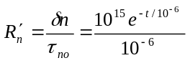cms
For 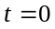, 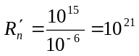cms
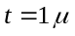s,
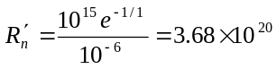cms
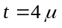s,
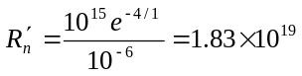cms
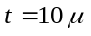s,
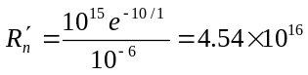cms
_______________________________________

Ex 6.2
- 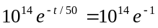
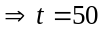ns
- 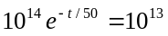
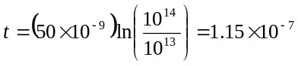s
or 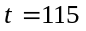ns
_______________________________________

Ex 6.3
- 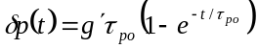
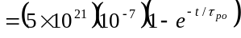
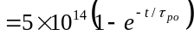
(i) 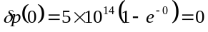
(ii) 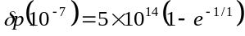
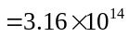cm
(iii) 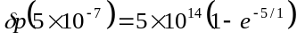
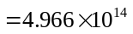cm
(iv)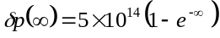
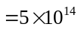cm
- 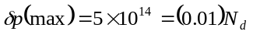
Yes, low-injection condition is met.
_______________________________________

Ex 6.4
- 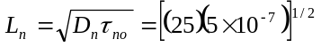
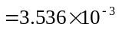cm
or 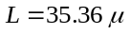m
- 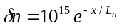 (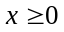)
or 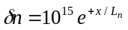 (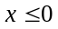)
(i)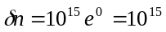cm
(ii)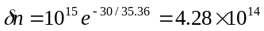cm
(iii)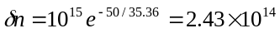cm
(iv)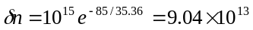cm
(v)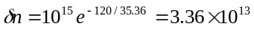cm
_______________________________________

Ex 6.5
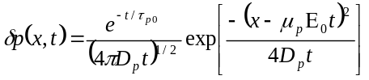
- 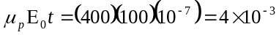cm
or 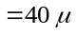m
(i)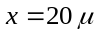m.
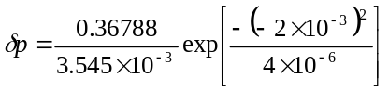
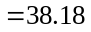
(ii)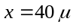m,
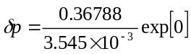
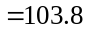
(iii)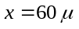m,
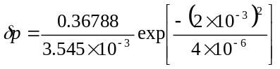
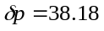
(b)m
(i)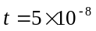s,
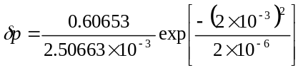
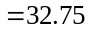

(ii)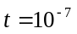s,
(iii)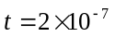s,
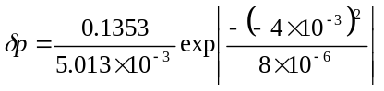
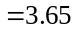
_______________________________________

Ex 6.6
- For 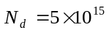cm in GaAs, from
Figure 5.3, 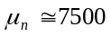cm/V-s.
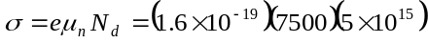
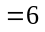(-cm)
Then 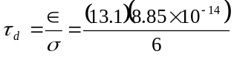
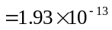s
or 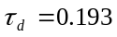ps
- For 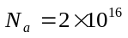cm in silicon, from
Figure 5.3, 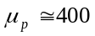cm/V-s.
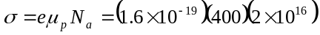
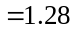(-cm)
Then 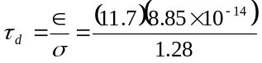
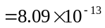s
or 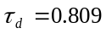ps
_______________________________________

Ex 6.7
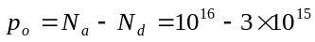
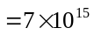cm
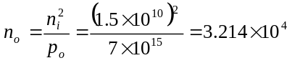cm
- In thermal equilibrium,
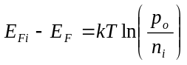
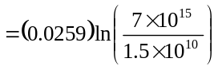
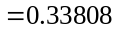eV

- Quasi-Fermi levels,
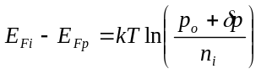
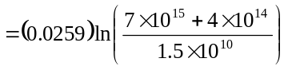
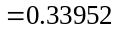eV
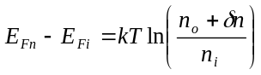
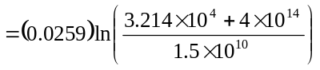
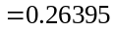eV
_______________________________________

Ex 6.8
n-type; 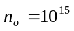cm, 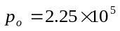cm
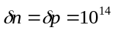cm,
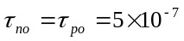s
We have
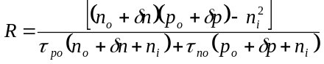
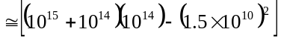
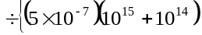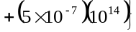
or
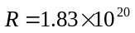cms
_______________________________________

Ex 6.9
- For 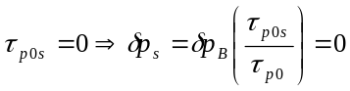
From Equation (6.109),
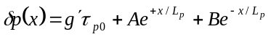
As 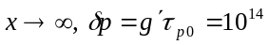cm
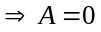
As 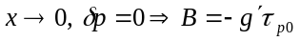
Then 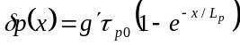
- 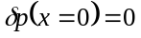
- 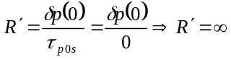
Note: 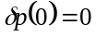is a result of 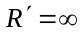.
_______________________________________

Ex 6.10
- 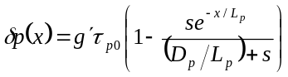
(i) For ,
(ii) For 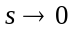,
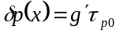

(i) For ,
(ii) For , 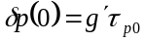,
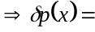constant
_______________________________________

Test Your Understanding Solutions

TYU 6.1
- p-type; Minority carriers = electrons
- 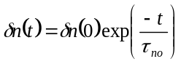
Then
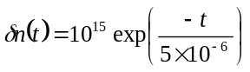cm
_______________________________________

TYU 6.2
- p-type; Minority carriers = electrons
- 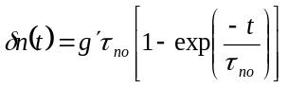
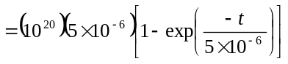
or 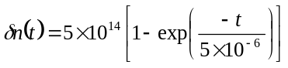
- As , 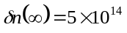cm
_______________________________________

TYU 6.3
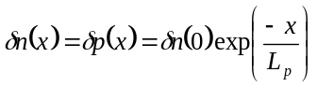
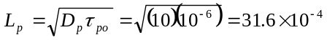cm
Then
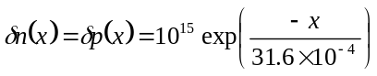cm
_______________________________________

TYU 6.4
n-type; Minority carriers = holes
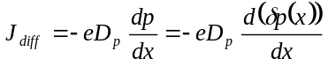
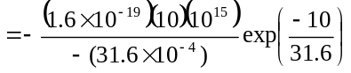
Then hole diffusion current density
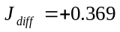A/cm
We have
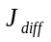(electrons)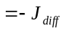(holes)
Then electron diffusion current density
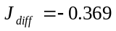A/cm
_______________________________________

TYU 6.5
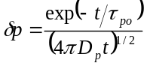
- 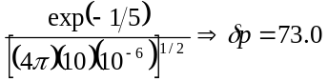
- 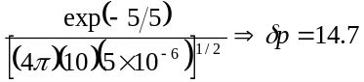
- 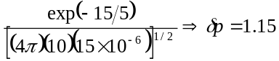
- 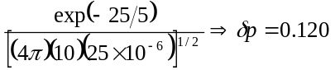
Now
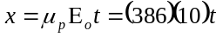
Then
- 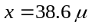m
- 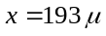m
- 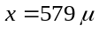m
- 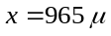m
_______________________________________

TYU 6.6
Using the results from TYU 6.5, we find
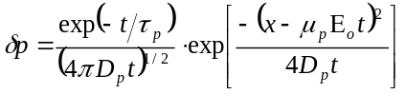
- (i) 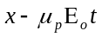
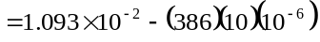
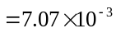
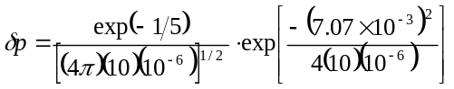
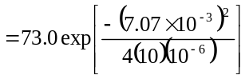
or
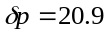
(ii)
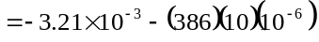
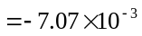
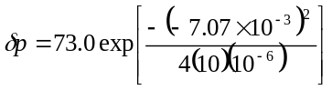
or
- (i)
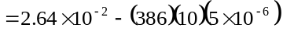
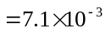
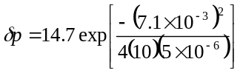
or
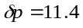
(ii)
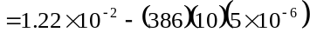
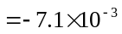
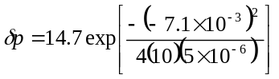
or

- (i)
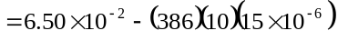
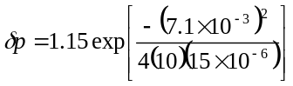
or
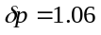
(ii)
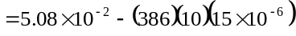
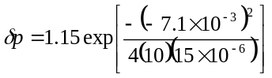
or
_______________________________________

